Vulnerability Assessment Report
Date: January 26, 2026
Target: DVWA
Tool Used: Burp Suite Community
Analyst: Nishanth C

1. Executive Summary
A security assessment was conducted on the OWASP Juice Shop application to identify critical web vulnerabilities. The assessment confirmed that the application is susceptible to SQL Injection, allowing unauthorized administrative access, and Cross-Site Scripting (XSS), posing a risk to user session integrity.

2.1.Setup vulnerable app (DVWA / Juice Shop)
Step 1: Start required services
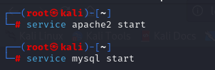
Step 2: Open DVWA in Browser
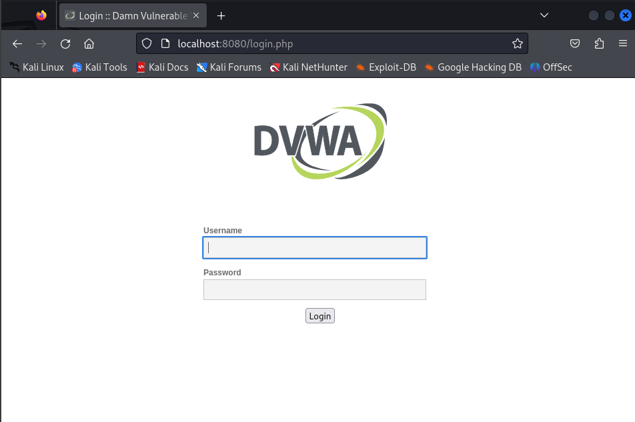

Step 3: Login to DVWA
Step 4: Configure DVWA
Go to DVWA Security
Set Security Level → Low
Click Submit
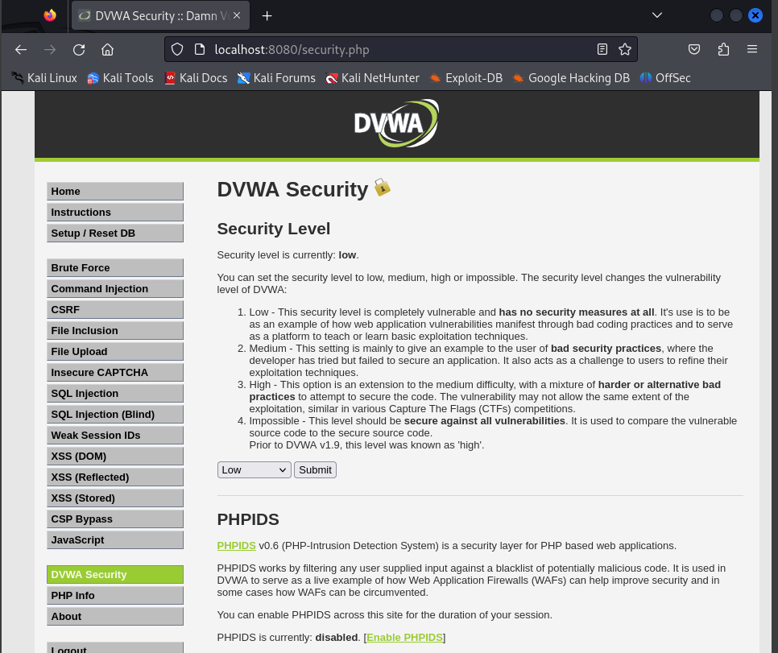

2.2.Intercept requests using Burp.
Step 5: Open Burp Suite
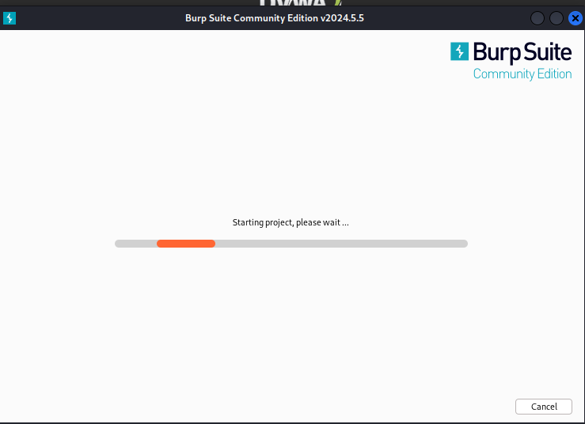

Step 6: Turn ON Intercept
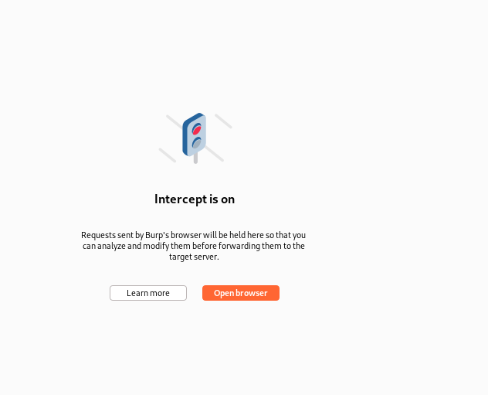
Step 7: Configure Firefox Proxy
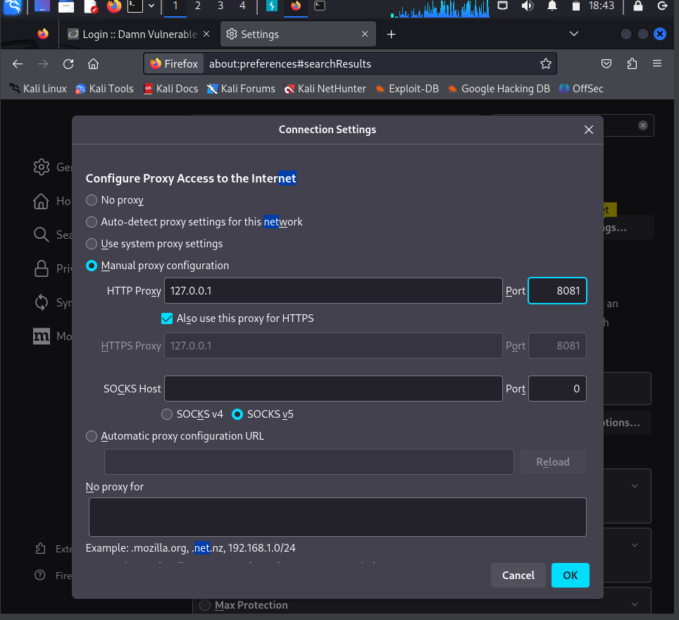
Step 8: Open DVWA in Browser
Step 9: View Intercepted Request in Burp
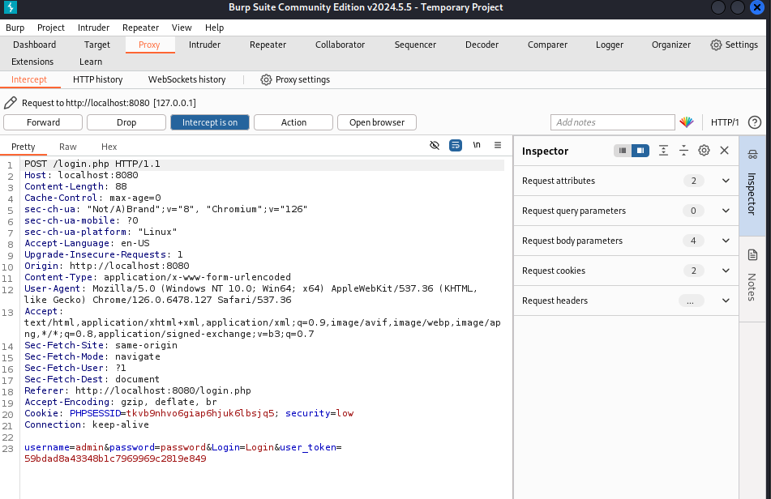
Step 10: Forward the Request
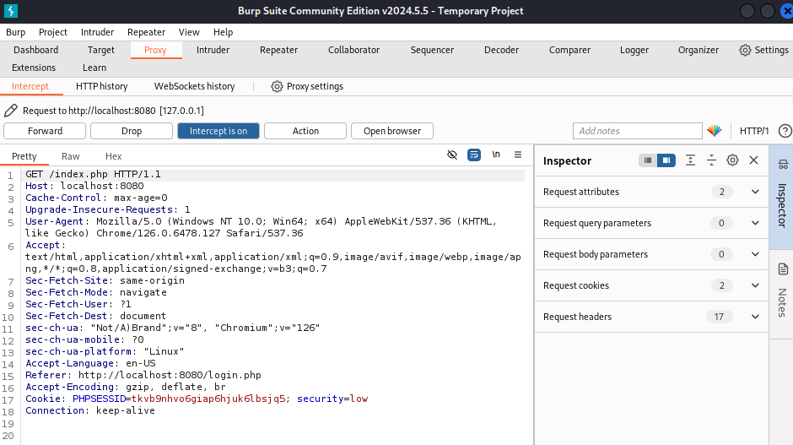
2.3.Test SQL Injection
Step 11: Open the SQL Injection Module
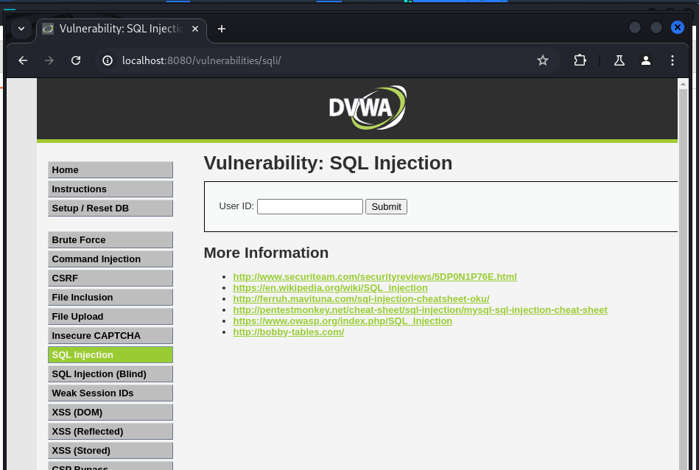
Step 12: Start Burp Interception
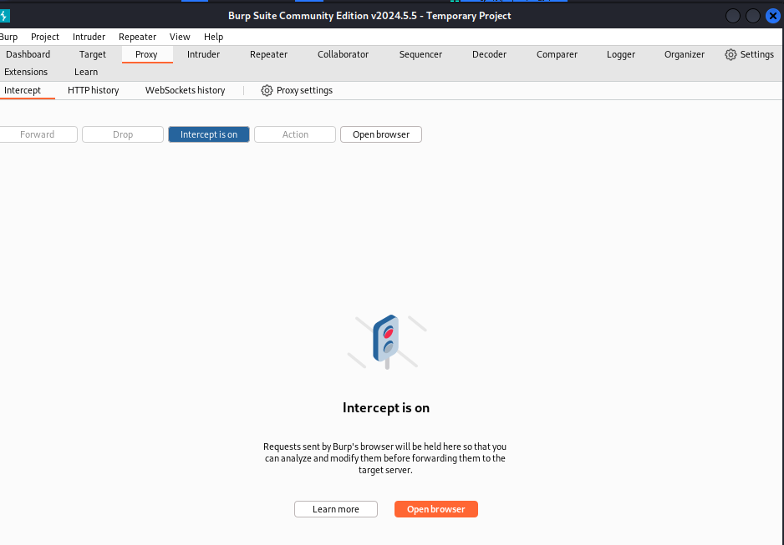
Step 13: Send a Normal Request
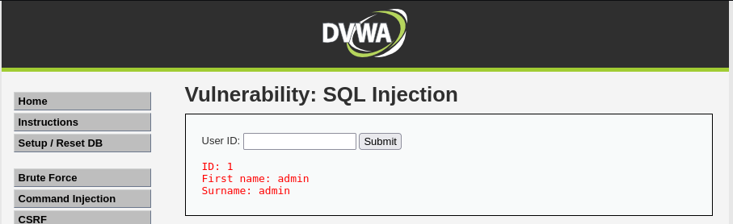
Step 14: Intercept the Request in Burp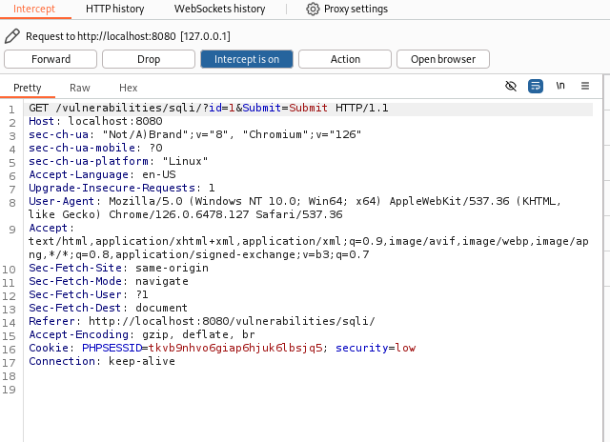
Step 15: Perform SQL Injection
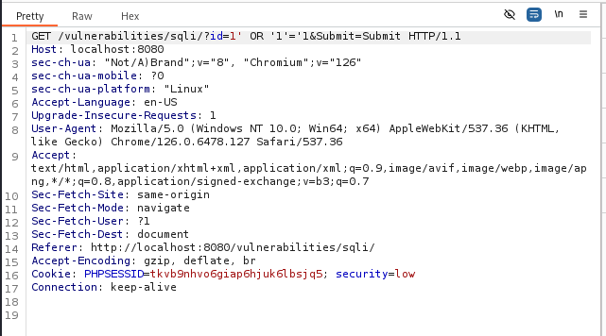

Step 16: Observe the Result
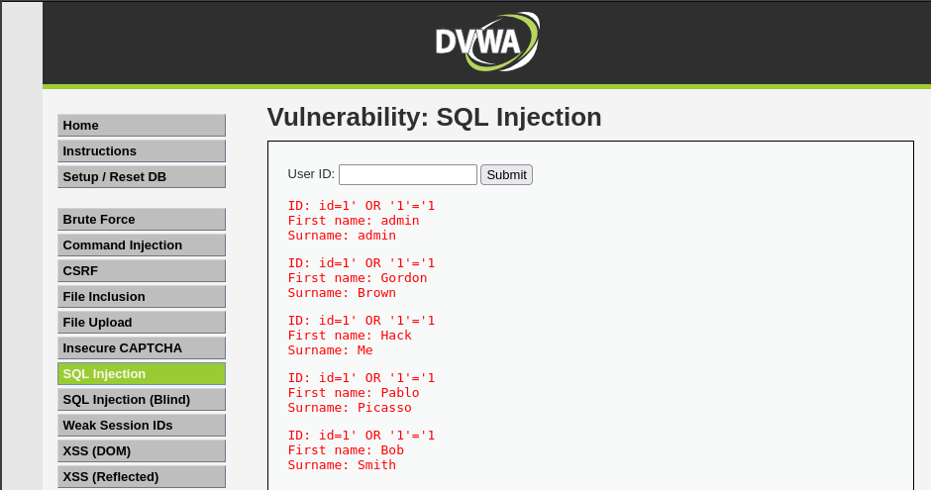
Step 17: Optional Payloads
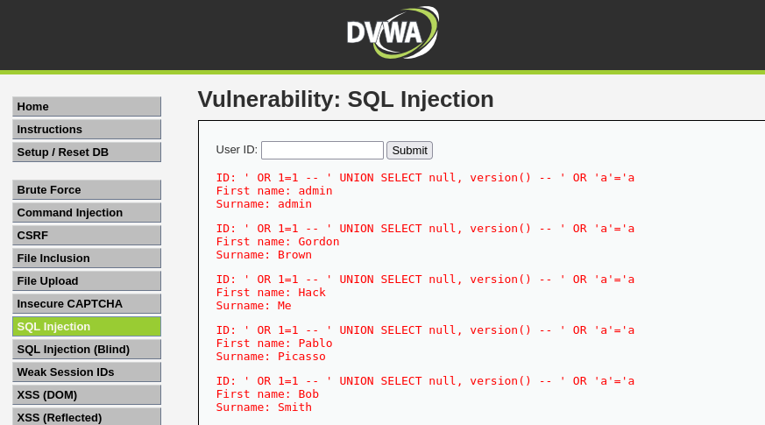

2.4.Test XSS
Step 18: Open XSS Module in DVWA
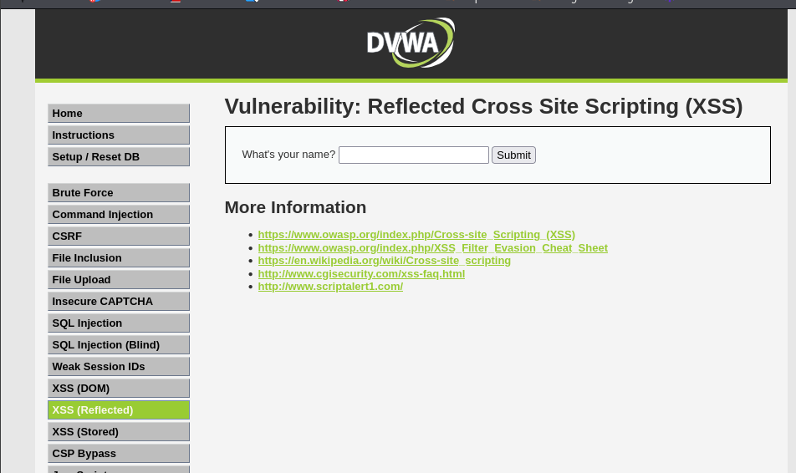
Step 19: Turn ON Burp Intercept
Step 20: Send Normal Input
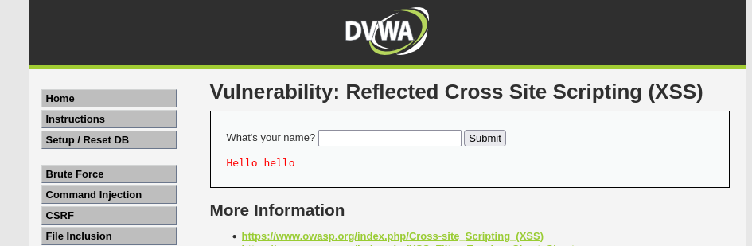
Step 21: Inject XSS Payload
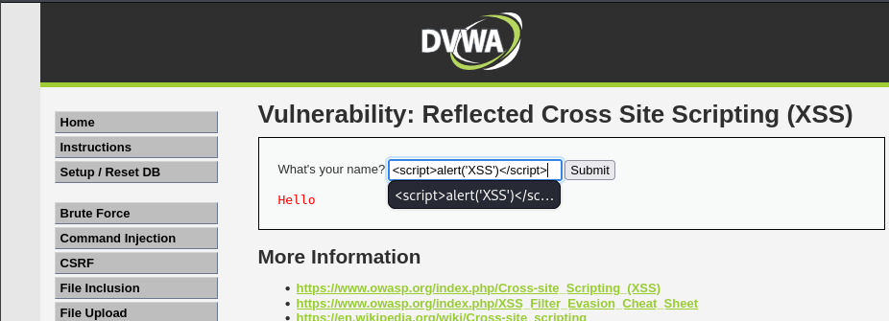
Step 22: Observe Browser Response
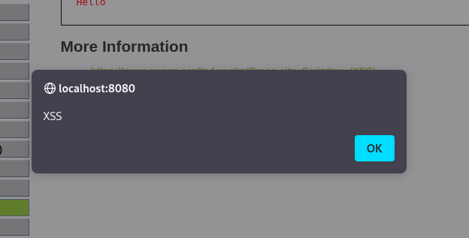
Step 23: Observe the Request in Burp
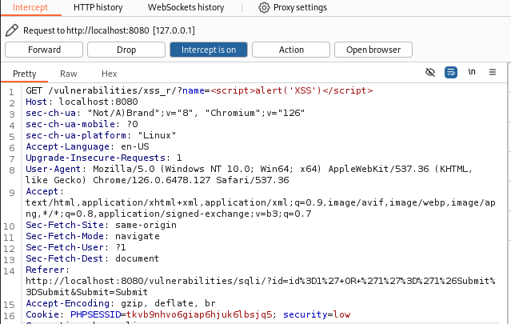

Step 24: Test Stored XSS
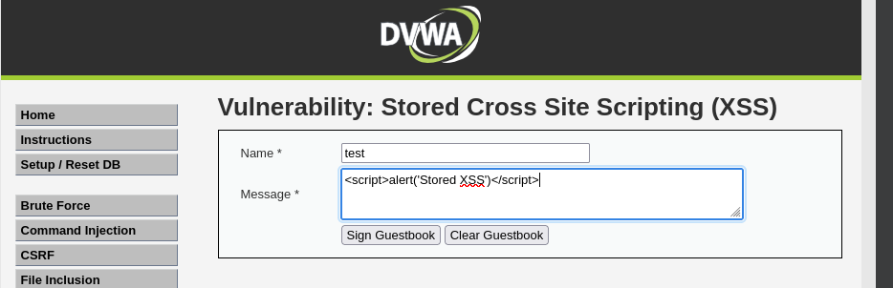

3. Technical Findings
Finding #1: SQL Injection (Authentication Bypass)
- Severity: Critical
- Location: Login Page (Email Field)
- Vulnerability Description: The login mechanism fails to sanitize user input in the "Email" field. By injecting a tautology (1=1), the authentication logic was bypassed, granting full administrative access without a valid password.
- Evidence (Payload Used):
SQL
' OR 1=1 --
Result: Successfully logged in as the Administrator account (admin@juice-sh.op).
- Impact: Complete system compromise. An attacker can access all user data, modify orders, and control the application.
- Remediation:
  - Use Parameterized Queries (Prepared Statements) for all database interactions.
  - Never concatenate user input directly into SQL strings.
Finding #2: Reflected Cross-Site Scripting (XSS)
- Severity: High
- Location: What’s your Name textfield.
- Vulnerability Description: The search functionality reflects user input directly into the Document Object Model (DOM) without proper output encoding. This allows an attacker to inject arbitrary HTML frames and JavaScript.
- Evidence (Payload Used):
HTML
<iframe src="javascript:alert('XSS')">
Result: The browser executed the JavaScript, displaying an alert popup.
- Impact: Phishing and Session Hijacking. Attackers could construct a malicious link (e.g., juice-shop.com/#/search?q=<script>...) to steal user cookies or redirect users to fake login pages.
- Remediation:
  - Implement Context-Aware Output Encoding (e.g., converting < to &lt;).
  - Use a modern framework's auto-sanitization features (e.g., Angular's built-in XSS protection) correctly.

4. Conclusion
The Juice Shop application contains critical flaws in its authentication and input handling layers. The SQL Injection vulnerability represents an immediate threat to the confidentiality and integrity of the platform and should be patched immediately.

